Parent Handbook

# Get Creative Holiday Club

Welcome to Get Creative Holiday Club! We are delighted to have your child join us for a fun-filled, safe, and creative experience. This handbook provides important information to help you and your child prepare for their time with us.

# 1. About Us

Get Creative Holiday Club offers engaging and creative childcare for children aged 4–11 years. Our programme includes arts and crafts, games, outdoor play, themed days, and much more! We are committed to providing a nurturing environment where children can learn, play, and make new friends.

# 2. Contact Information

Club Manager: Callum Hudson

Phone: 07851431859

Email: getcreativeholidayclub@gmail.com

Venue Address: Iveson Primary School, Iveson Rise, Leeds, LS166LW

Website: [Home - Get Creative Holiday Club](https://www.getcreativeholidayclub.co.uk/)

# 3. Opening Times & Dates and Drop Off and Pick Up

Please use the main entrance for drop off and pick up, the gates will be open between 08.00-09.00 and 16.00-17.00, if arriving before or after these times, please call Callum Hudson on the phone number provided. Follow signs for The Nest where staff will meet you to take your child to the school hall where the holiday club will be taking part. Please follow the blue line once in the school grounds to the entrance door for The Nest.

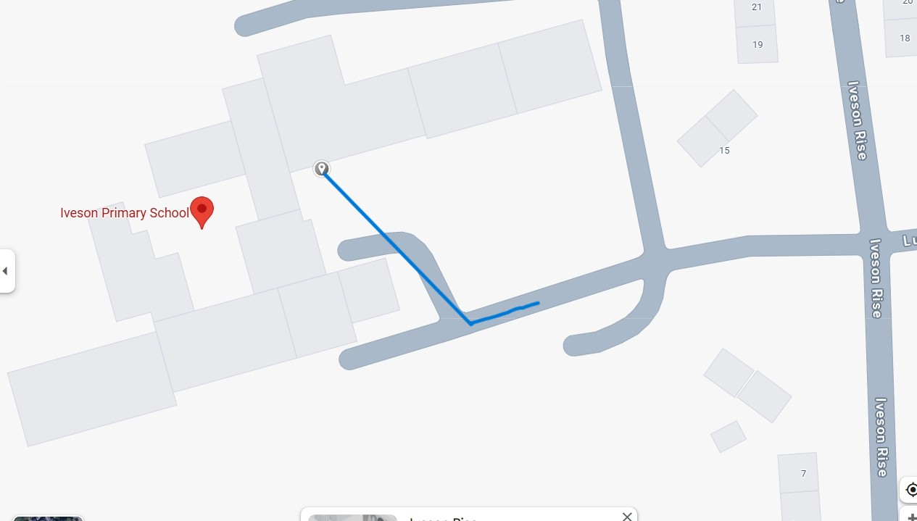

We operate during the school holidays (excluding bank holidays).

Opening hours: 8:00am – 5:00pm

# 4. Daily Routine

Here’s what a typical day at Get Creative looks like:

8:00–9:00am – Arrival and free play

9:00–10:30am – Morning creative activity

10:30–10:45am – Snack break

10:45am–12:00pm – Outdoor games or workshops

12:00–1:00pm – Lunch

1:00–2:45pm – Afternoon themed activity

2:45–3:00pm – Snack break

3:00–4.00pm – Quiet activities

4.00-5.00- Free play and pick up times

# 5. What to Bring

• A labelled water bottle

• A healthy packed lunch and snacks **(no nuts)**

• Weather-appropriate clothing and footwear

• Sun hat and sun cream (in warmer months)

• Spare clothes (especially for younger children)

# 6. Behaviour & Expectations

We promote positive behaviour and encourage kindness, respect, and cooperation. We use praise and reward systems to reinforce good behaviour. Serious incidents are recorded and discussed with parents.

# 7. Safeguarding & Health

Your child’s safety is our top priority. All staff are DBS-checked and trained in safeguarding. We have clear procedures for managing illness, accidents, and emergencies. If your child is unwell, please keep them at home and inform us as soon as possible.

# 8. Payment & Vouchers

Fees are payable in advance through our online booking system. We accept a range of childcare vouchers and Tax-Free Childcare. Please notify us during booking if you are using vouchers.

# 9. Policies & Procedures

Our key policies (including safeguarding, health and safety, behaviour management, and complaints) are available on request and can be found on our website.

# 10. Communication

We keep parents updated via email and our website. For urgent queries, please contact the Club Manager directly. We value your feedback and welcome suggestions to improve our service.

# 11. Consent & Medical Information

Please ensure that all consent forms and medical details are completed and up-to-date before your child attends.

# 12. Complaints

We take complaints seriously and aim to resolve them quickly. Please speak to the Club Manager in the first instance. A formal complaints procedure is also available.

Thank you for choosing Get Creative Holiday Club. We look forward to a fun and safe holiday experience with your child!